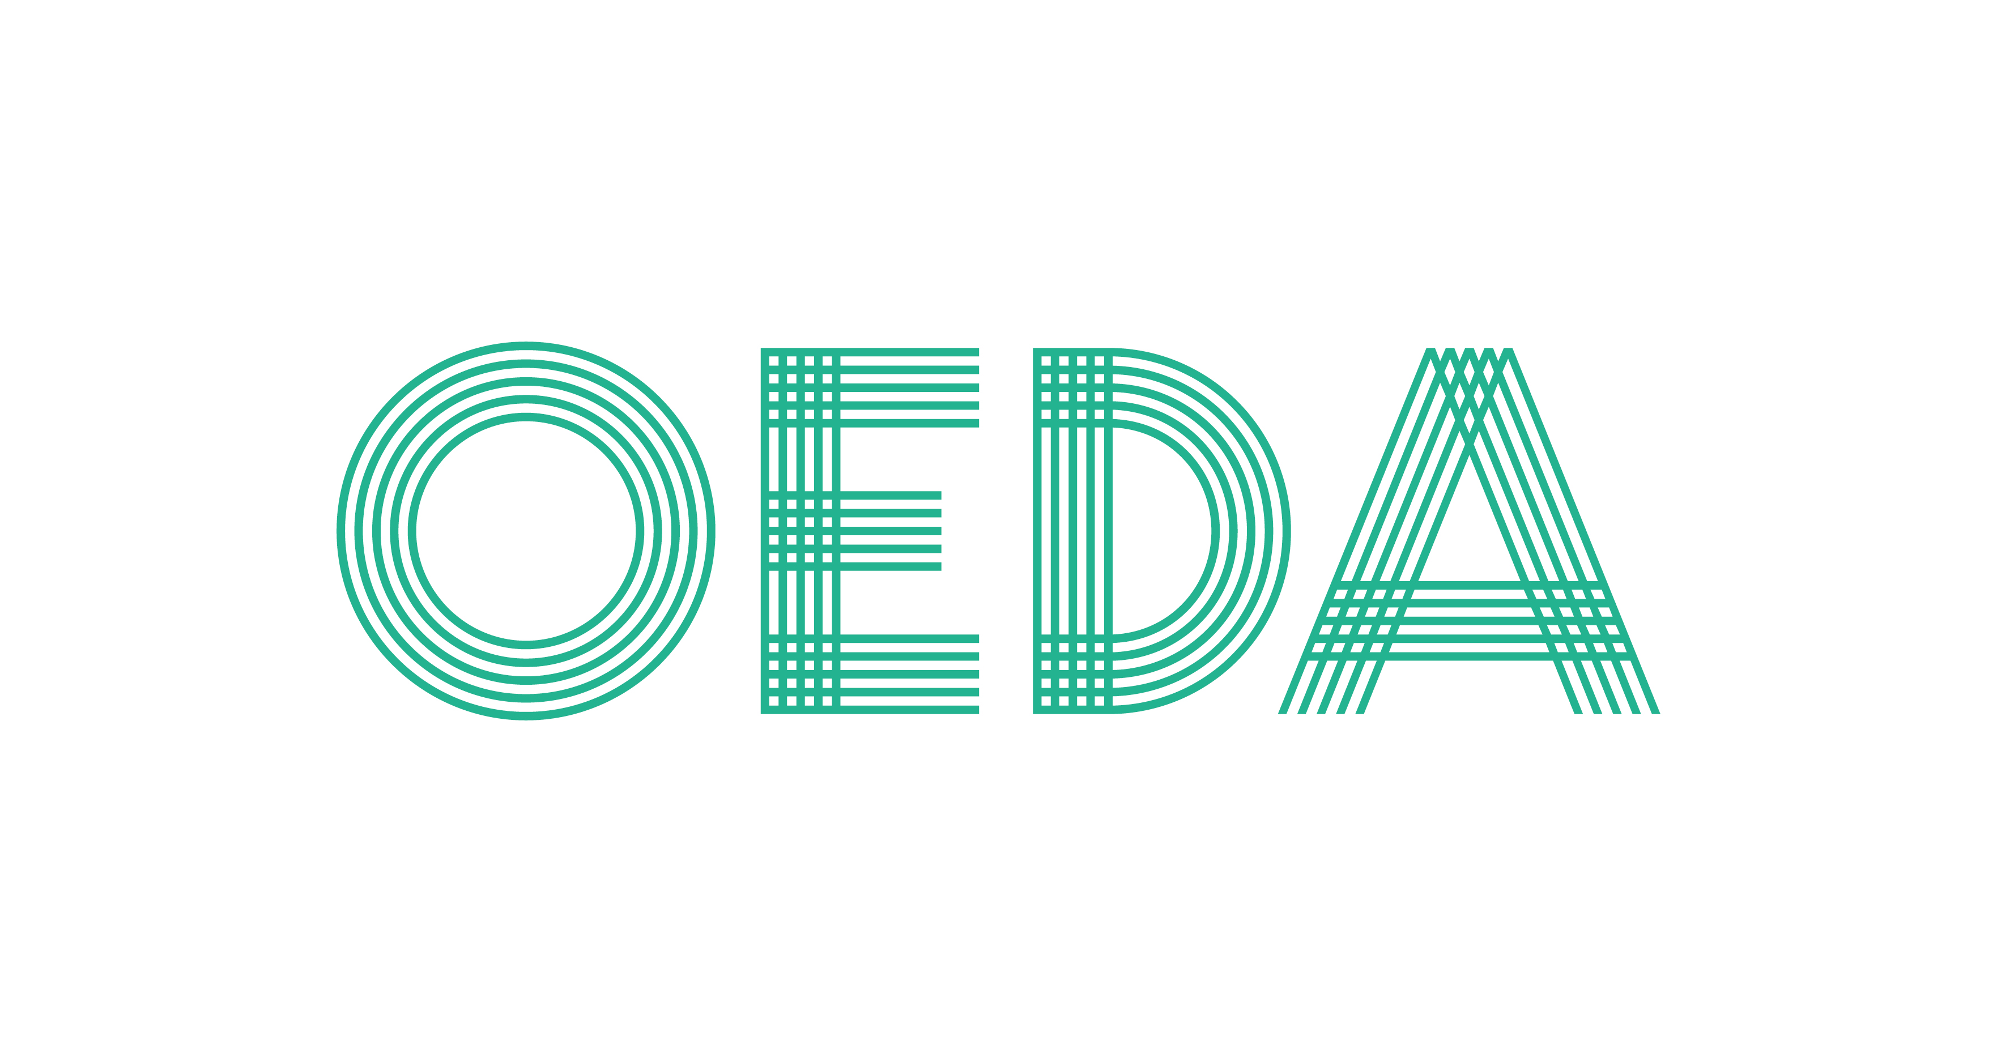
2018 Excellence Awards Nomination Form
Best Project

This award recognizes outstanding and innovative projects in economic and business development that retain or generate jobs and investment. This can be anything from a retention project to new facility construction, redevelopment (brownfield or otherwise) or an historic project. The award determination is not dependent on the number of jobs created or retained or the amount of total investment. Rather, this award will showcase a unique approach to the project, which can include a public-private partnership, local collaboration, and innovative financing and/or incentives. The project must have been completed in the last 18 months, however there are no time limits or constraints on the total timeline of the project (especially in the case of brownfield redevelopment, infrastructure projects, etc.).

Please select/complete one:
- OEDA member submission
- Non-member submission – please invoice me at (email address) _____________________________________

Nominations are free for current OEDA members. The nomination fee for non-members is $75 per entry (nominator and/or nominee must be an OEDA member to qualify for no entry fee). Non-members will be invoiced for the $75 fee per entry. Payment is due July 31, 2018.

Nominee Information:
- Name/Organization/Project Name (exactly as it should be displayed on materials):

________________________________________________________________________________________________

Nominator/Contact information – who should be contacted with questions and/or notification that this nominee is named a finalist or winner:

- Name & Organization __________________________________________________________________________

- Telephone & Email: ____________________________________________________________________________
Required information – please attach a narrative that addresses the following qualifications:

- Describe what the nominated entity has done to deserve recognition as Best Project.
- Why was/is this effort unique or worthy of special recognition?
- Has the project produced results yet? If so, please describe.

Required Formatting - The narrative is limited to 5 double-spaced single-sided 8.5 x 11” pages with 12 point text font and 1” margins. Attachments are limited to 5 pages. Please note that these requirements must be adhered to. Any alterations to these requirements will disqualify your nomination.

Please submit your nomination(s) by July 31, 2018 via mail or email to:
Ohio Economic Development Association
17 High Street, Suite 200, Columbus, OH 43215
EMAIL: OEDA@AssnOffices.com
Questions? Please contact the OEDA offices at 614-228-4706.

